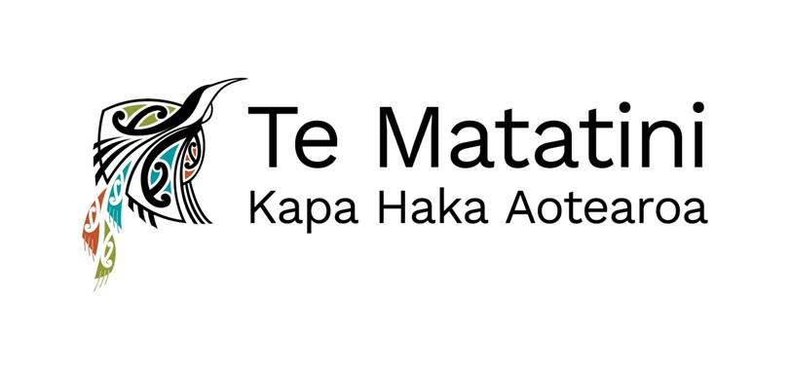

Kaihautū Mahi | Director of Operations

- Full -time
- Based in Te Whanganui-a-Tara/Wellington

Te Matatini is dedicated to the development, growth, and celebration of kapa haka, the traditional Māori performing arts, both nationally and internationally.

The Kaihautū Mahi | Director of Operations plays a key role in transforming the Te Matatini strategic vision into annual work plans and leading and managing the operations to effectively achieve strategic objectives.

You will oversee the establishment and management of efficient operational processes and systems and support the Business Support and Corporate Services teams foster a high-performance culture through effective leadership, collaboration and mentoring.

Additionally, you will cultivate and maintain positive relationships across a range of sectors that include the kapa haka community, iwi, NGOs and the public sector.

You will be recognised as a leader in your specific field of work and have extensive experience managing the operations of a growing organisation and understanding of business cycles which include strategy, planning prioritising and reporting.

A deep understanding and appreciation of te ao Māori, with respect for Māori cultural values and customs, is required, along with proficiency in Te Reo Māori.

For more information contact Marama Steele on 021 505 509, and to apply please email your CV and cover letter to marama.atahaia@gmail.com.

Application close 5pm, Monday 5 August 2024.

