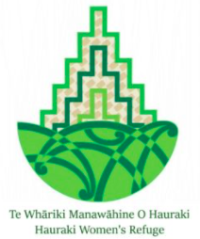

**Te Whāriki Manawāhine o Hauraki**

Te Whāriki Manawāhine o Hauraki Women’s Refuge (Te Whāriki) is a leader of innovative, whānau-centred approaches that support whānau to address and heal from historical and intergenerational trauma, leading to Mauri Ora.

Our organisation is in a positive growth phase, with two newly created roles available. We are looking for individuals who are innovative whānau activators, flexible in their approach, and capable of working with the complex levels of harm suffered by whānau. These roles are ideal for those committed to healing and recovery from a Te Ao Māori values perspective. We seek:

* **He Kaiārataki Wāhine** – This senior role calls for an experienced practitioner dedicated to supporting wāhine and their whānau in healing from traumatic experiences. Candidates should have extensive experience in counselling, including supporting whānau move through any current and historical impacts arising from sexual violence. As an experienced practitioner you will be adept at delivering support programmes using practices and values from Te Ao Māori.
* **He Pou Takawaenga** – This community-focused position requires a person experienced in on-the-ground support of tangata whenua development initiatives, empowering whānau Māori to implement their own solutions to the issues they face. You should have a proven ability to make informed decisions and accurately assess community needs, understanding the importance of adapting and being responsive to the evolving needs of transformative healing.

For more information about each role, or to submit your CV and cover letter, contact Marama Steele on 021 505 509 or [marama.atahaia@gmail.com](mailto:marama.atahaia@gmail.com).

Applications close: 5pm, Monday 22 July 2024.